**Manage client`s personal data in Bitrix24**

General Data Protection Regulation came into effect on May 25, 2018. This application enables you to meet these requirements with respect to client`s personal data in Bitrix24.

**Anonymize client`s personal data**

CRM Slider panel is accessible only from the following CRM entities: Lead, Contact, Company

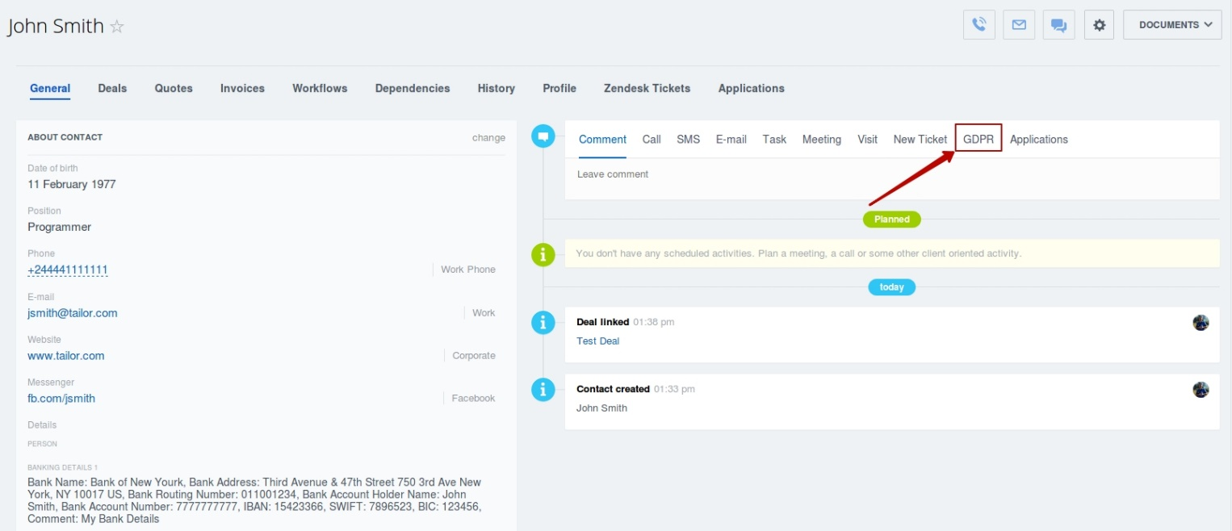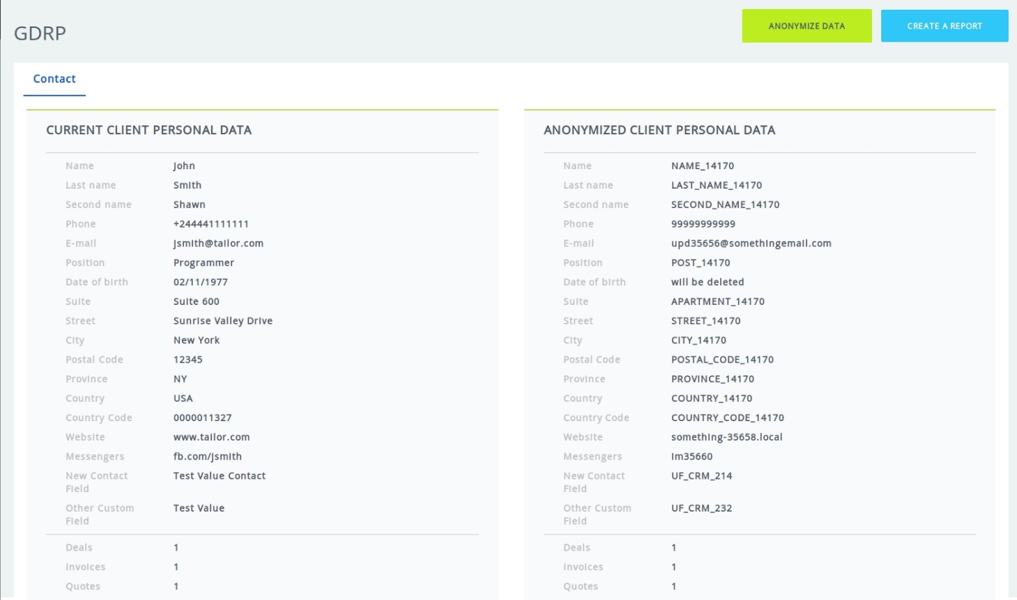

**Select custom fields to be anonymized**

Custom fields to be anonymized along with standard fields.

